Vprofile project set up in local machine

Project overview/stack:
- Creating a web application its social networking site written by developers in java language
- User opens the browser and login wit IP address, we use nginx service to create load balancing experience
- It will route the request to tomcat service. It’s a java web application service.
- We use RabbitMQ service which is connected to tomcat. It’s a dummy and message broker.
- We have another MYSQL db connecter to tomcat application
- The application which is running on tomcat, user will logon with username and password. So it will run sql query and store the user info in db.so the details will sent from sql to tomcat.
Flow of execution:
- Clonesource code
- Cd to vagrant dir
- Bring vm up
- Validate
- Setupall service
  - Mysql
  - Memcached
  - Rabbit MQ
  - Tomcat
  - Nginix
  - And build and deploy
And finally we will verify in browser

Clone the repo into use base macine
https://github.com/hkhcoder/vprofile-project
install all the vms and follow the steps mention on that pdf file
While setting up tomcat, CODE BUILD & DEPLOY (app01), change the password in below path
vi src/main/resources/application.properties

don’t remember any commands just follow the process.

Once all set up , use the nginx ip and search in chrome: username and pass: admin_vp

Setup using ec2 instances:

- Login to aws account
- Create key pairs
- Create security groups
- Launch instance with user data(bash script)
- Update ip to name mapping in route 53
- Built application from source code
- Upload to s3 bucket
- Download artifcat to tomcat ec2 instances
- Setup ELB with https(certificate from certificate manger)
- Map ELB endpoint to website name in godaddy DNS
- Verity
- Build auto scaling group for tomcat instances
Step 1-5:
Creating 3 security group for 1.application load balancers 2.autoscalling group( for tom cat instances) 3. backend-SG(for memchace rabiit mq and mysql instance)
1. http and https (both ipv4 and ipv6)
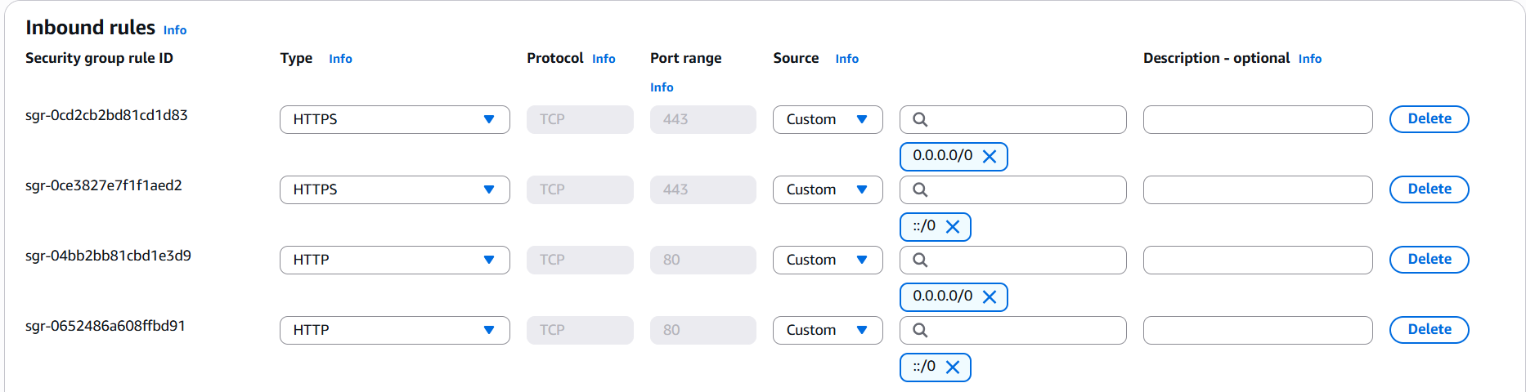
2.custom tcp (8080) (select load balancer SG(1st SG)) and 22 (myip)
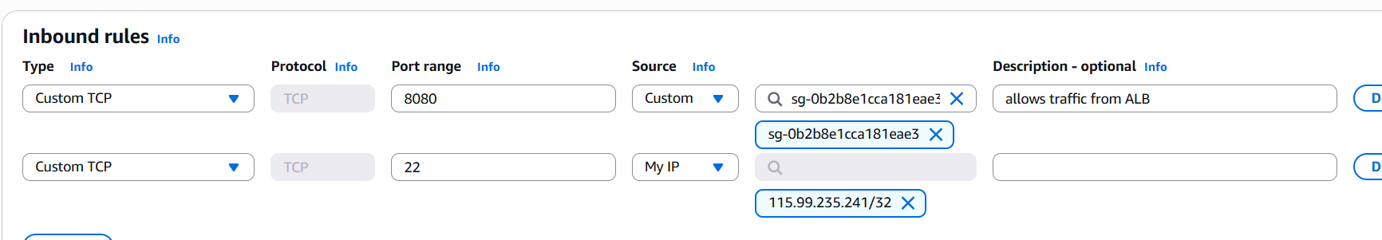
3.SG for backend instances (source will be tomcat app (2nd SG))
Port 11211 (memchace)
Port 5672(rabbitmq)
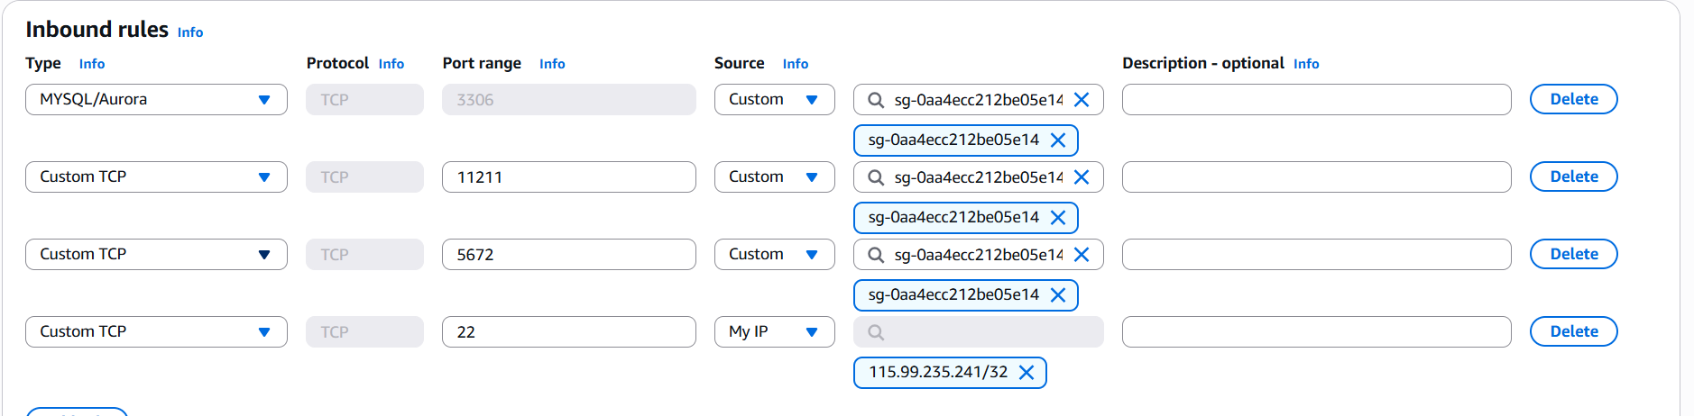
Also add 1 more rule (with same SG) allowing all traffic.
Now create key-pair(pem file)

Creating 4 instances for mysql, memchae, rabitmq ( backend Sg) and tomcat instances.(app sg)

Clone this link in vscode
https://github.com/hkhcoder/vprofile-project.git

and swith to awslift and shift brsnch userdata-->mysql.sh
note: use amazon linux as AMI for mysql, memchae, rabitmq and ubuntu for tomcat instances
in provizining copy the code from vscode(mysql.sh) repeat same thing for all instances.

Updating ip to name mapping in route 53 (creating domain for our project)
Create hosted zonegivename.in(vprofie.in)private hosted zoneregion (north.virginia) --> select fdefault vpc and create hostedzone.
go get the private ips for our instances not tomcat, we need to create records in route 53
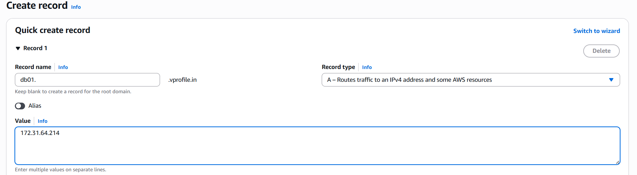

After creatring cross check pinging by logind on app01(tomcat instance)
Its ubuntu. Ping -c 4 db01.vprofile.in

Step 6-12:
Now, we need to built artifact from the source code and need to push in s3 bucket, from tomcat instance we need to fetch the artifact and deploy to tomcat services.
To connect with s3 bucket we nned IAM keys(store in our lapy) and roles for authentication,
Create 1 bucket and user in IAM service
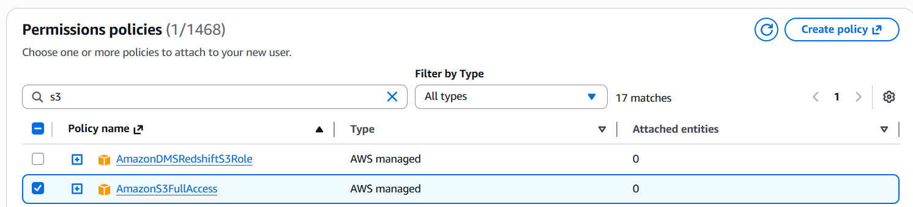
After creating user(give amazons3full access) create access key under security creds CLI and download the .csv file

Now need to create roles as well(give amazons3full access), after creating role appliy it to app01 instance(tomcat instance)
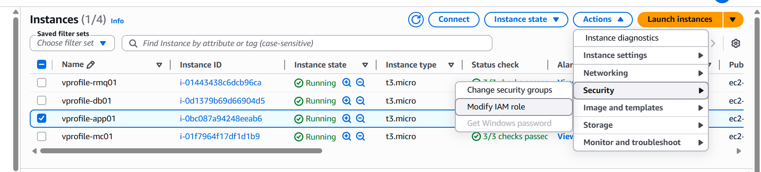

Now, we need maven , jdk and CLI to built artifact from source code
Edit the application.proprties like db01.vprofile.in in all instances places. (in vscode (just clone the repo))
In the same vs code cntl+shift+n select defaultprofile select gitviewterminal
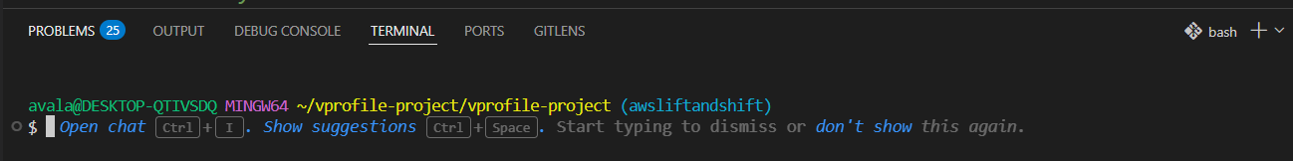
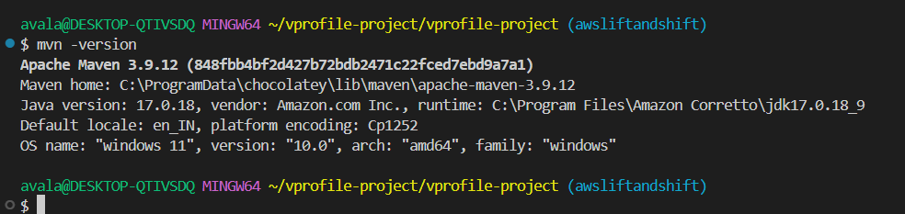

We should be in vprofile-project folder and follow below steps:
Mvn install
If built success u will see vprofile-v2.war artifact under target folder
And also run aws configure in vs coede and five access key infos u have downloaded in to ur base machine.
now copy thr .war file to s3 bucket u created with below command
Before copying we need to configure access key: aws configure
aws s3 cp target/vprofile-v2.war s3://vprofile-bucket-artifacts8765/
now login to app01 and check
before cecking install awscli
snap install aws-cli –classic

after that copy the .war file in s3 buct to this instances /tmp/ folder
aws s3 cp s3://vprofile-bucket-artifacts8765/vprofile-v2.war /tmp/
now we have to deploy the artifact from this tomcat instance
before that we nned to stop the tomcat service systemctl stop tomcat10
and open the home directory of tomcat ls /var/lib/tomcat10/webapps/ root (we have to remove it)
rm -rf /var/lib/tomcat10/webapps/ROOT
after removing copy that .war
cp /tmp/vprofile-v2.war /var/lib/tomcat10/webapps/ROOT.war
and start the service u will see root.war

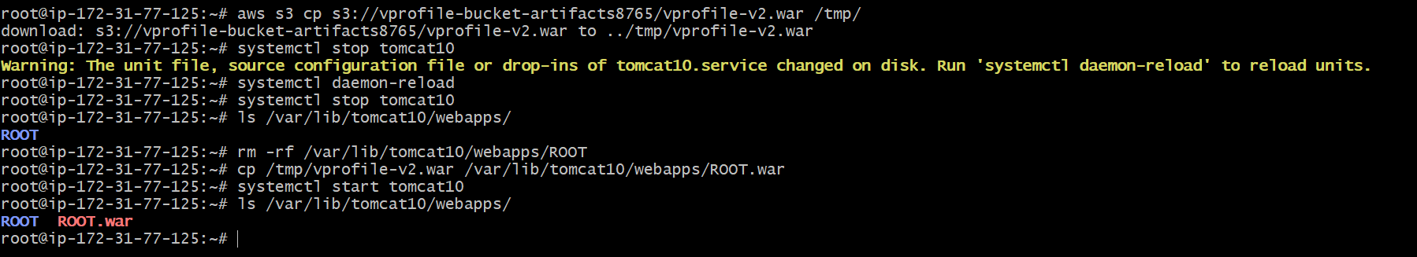

Now u can access the webpage with publicIP:8080 tomcat runs on port 8080.
http://100.53.22.69:8080/ just for confirmation.

